1. Write a LEX program which adds line numbers to the given C program file and display the same in the standard output.

# Input Source Program: (sample.c)

#define PI 3.14 #include<stdio.h> #include<conio.h> void main()

{ int a,b,c = 30;

printf("hello")

;

}

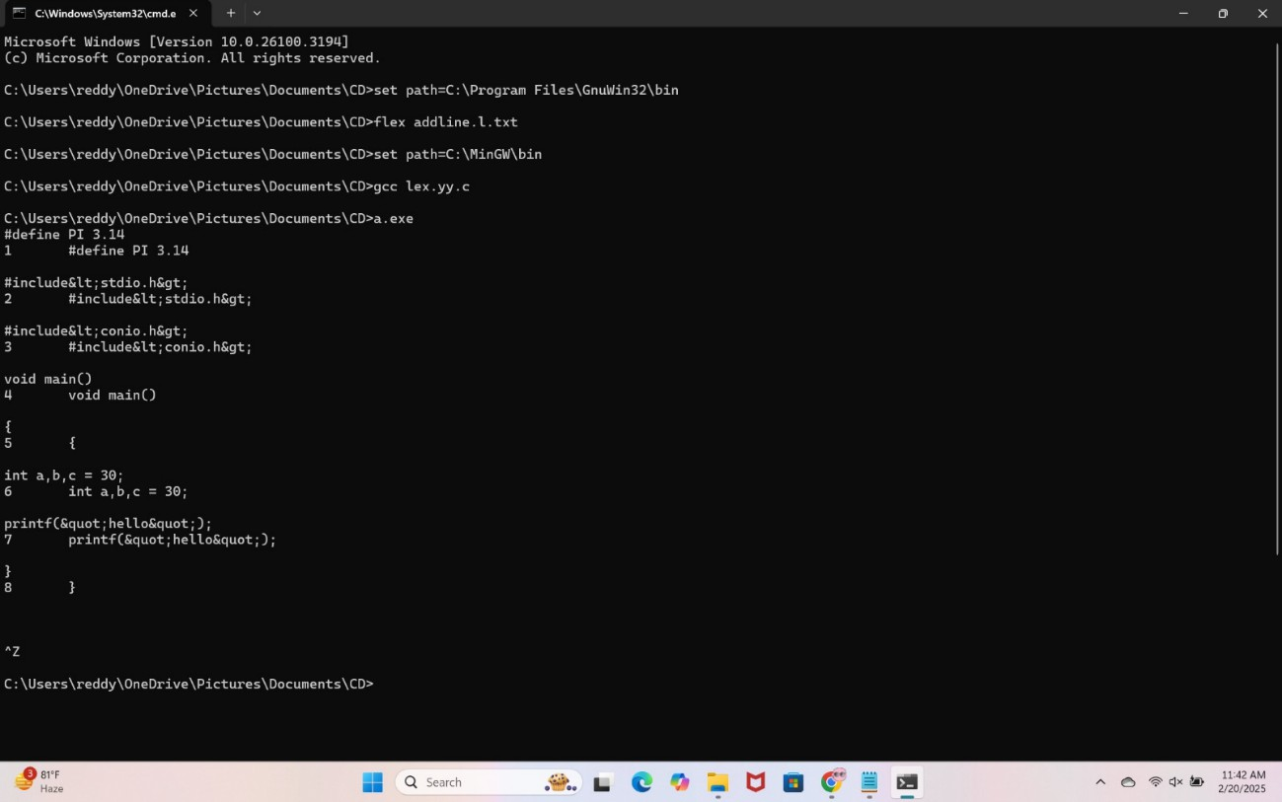

1. Write a LEX specification count the number of characters, number of lines & number of words.

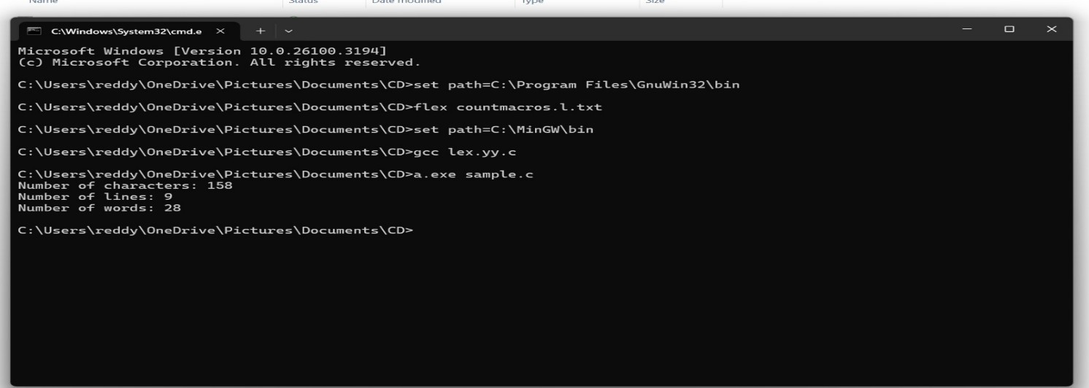

1. Write a LEX program to count the number of comment lines in a given C program and eliminate them and write into another file.

**Input Source File: (input.c)** #include<stdio.h> int main() { int a,b,c; /*varible declaration*/ printf(“enter two numbers”); scanf(“%d

%d”,&a,&b); c=a+b;//adding two numbers printf(“sum is

%d”,c); return 0;

}

1. Write a LEX program to identify the capital words from the given input.

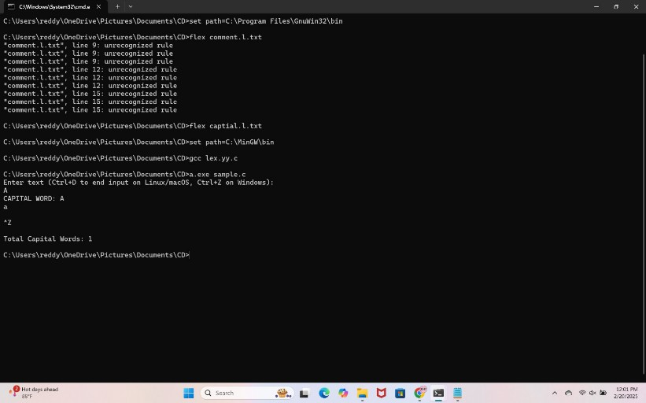

1. Write a LEX Program to check the email address is valid or not.

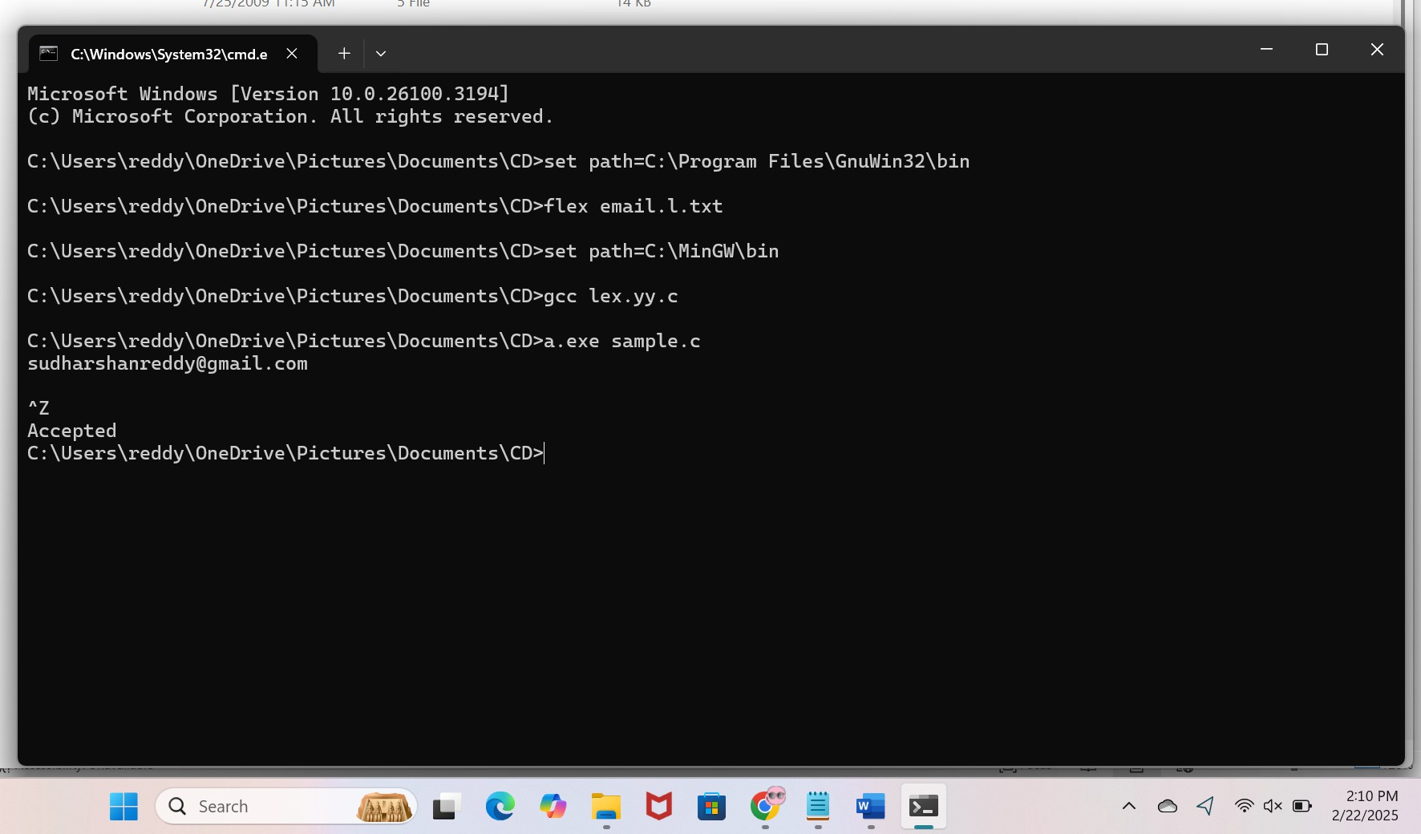

1. Write a LEX Program to convert the substring abc to ABC from the given input string.

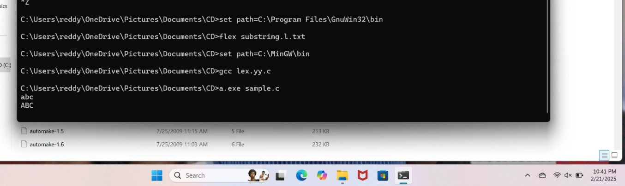

1. The Company ABC runs with employees with several departments. The Organization manager had all the mobile numbers of employees. Assume that you are the manager

and need to verify the valid mobile numbers because there may be some invalid numbers present. Implement a LEX program to check whether the mobile number is valid or not.

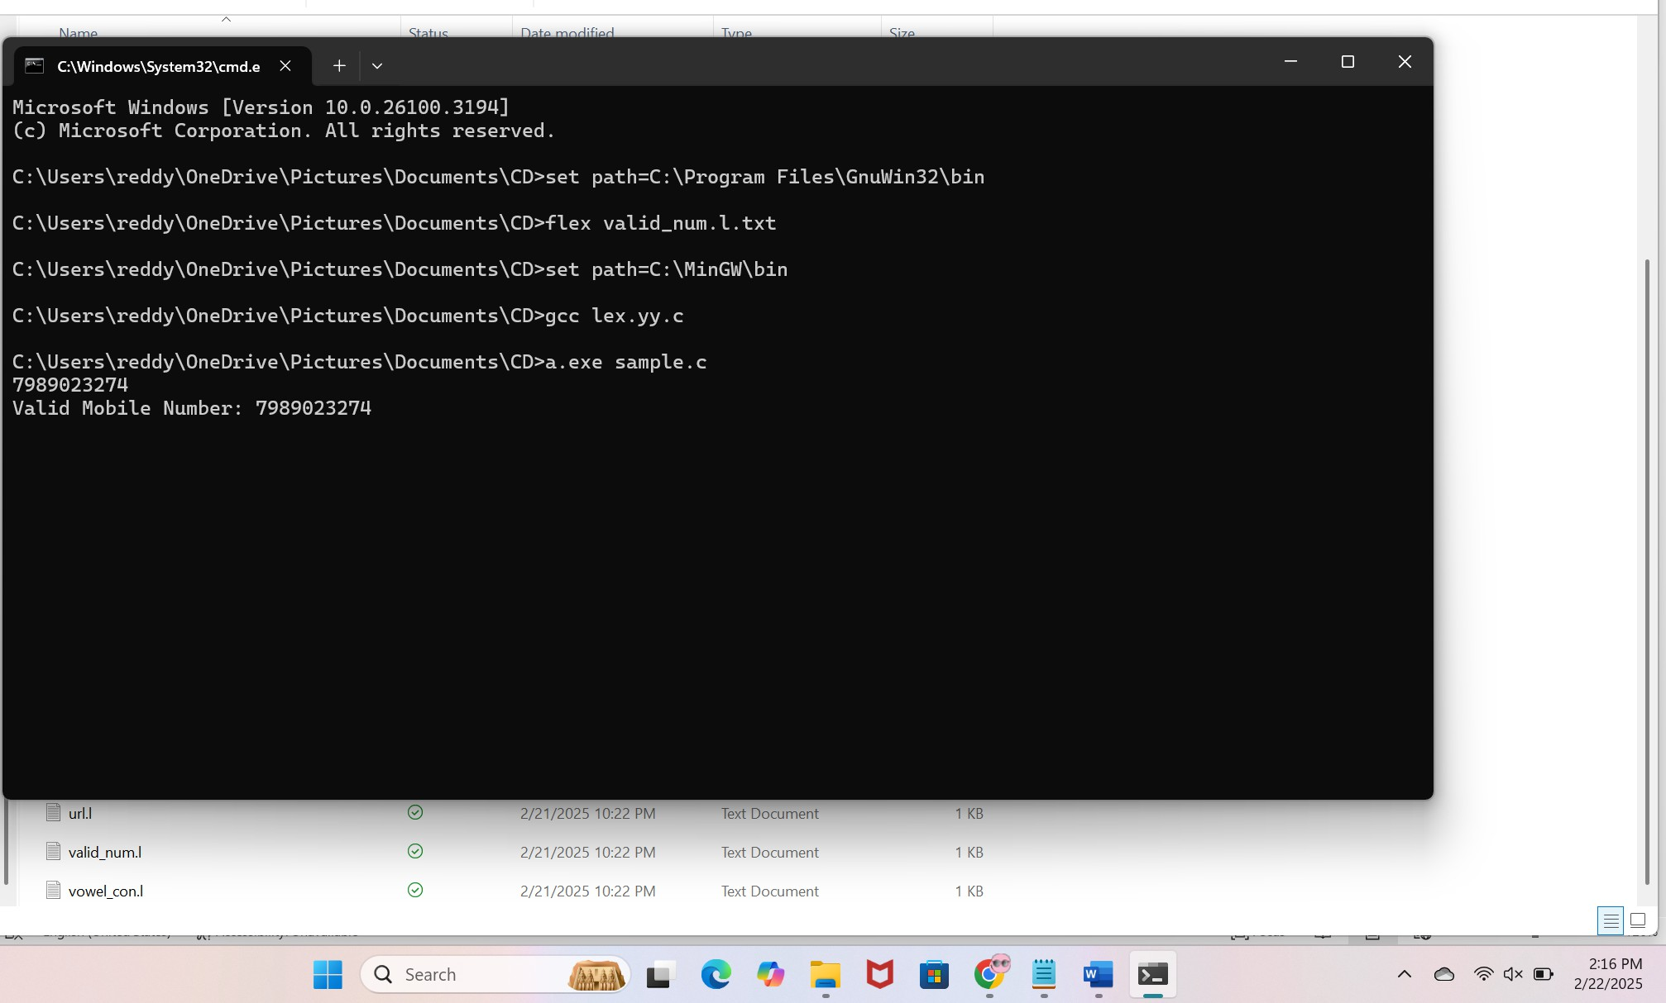

1. Implement Lexical Analyzer using LEX or FLEX (Fast Lexical Analyzer). The program should separate the tokens in the given C program and display with appropriate caption.

# Input Source Program: (sample.c)

#include<stdio.h> void main()

{

int a,b,c = 30; printf("hello");

}

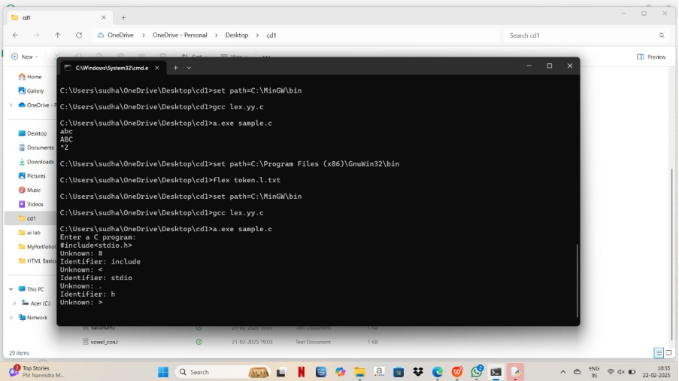

1. 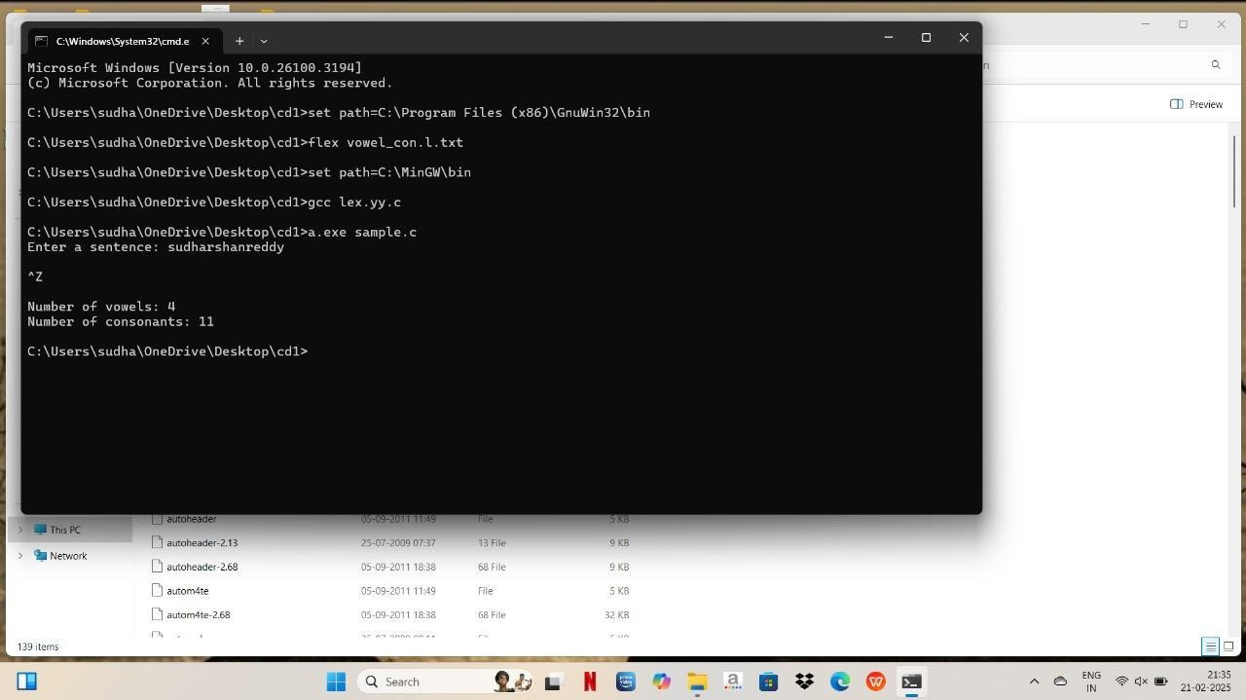In a class, an English teacher was teaching the vowels and consonants to the students. She says “Vowel sounds allow the air to flow freely, causing the chin to drop noticeably, whilst consonant sounds are produced by restricting the air flow”. As a class activity the students are asked to identify the vowels and consonants in the given word/sentence and count the number of elements in each. Write an algorithm to help the student to count the number of vowels and consonants in the given sentence.
2. Keywords are predefined, reserved words used in programming that have special meanings to the compiler. Keywords are part of the syntax and they cannot be used as an identifier. In general there are 32 keywords. The prime function of Lexical

Analyser is token Generation. Among the 6 types of tokens, differentiating Keyword and Identifier is a challenging issue. Thus write a LEX program to separate keywords and identifiers.

